**Outlook Profile Reset**

If users are connected to a computer network, outlook will get configured automatically. Sometimes user’s outlook is not working properly, in that case, we need to reset the outlook profile manually.

1> Go to the control panel and click on the mail.

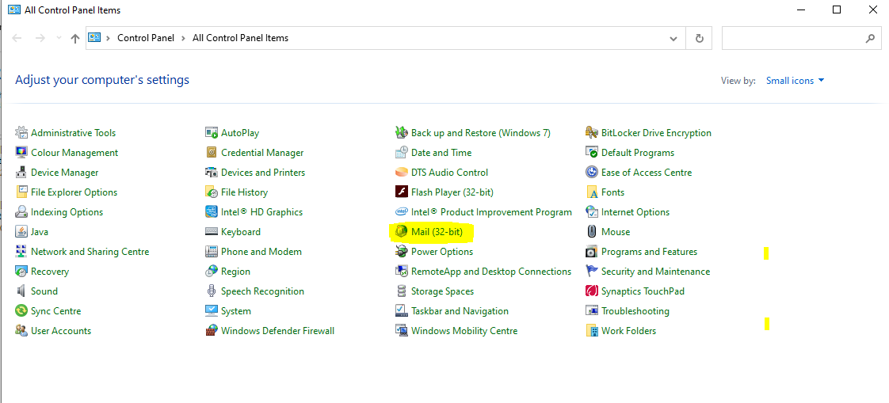

2> click on show profile

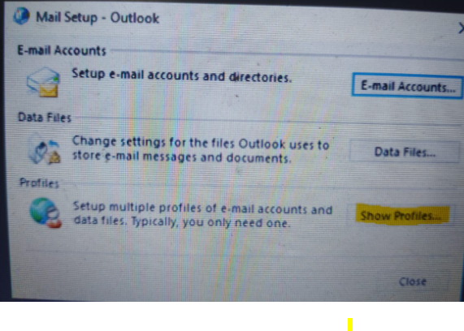

3> Click on Add > Enter the name and click on Ok.

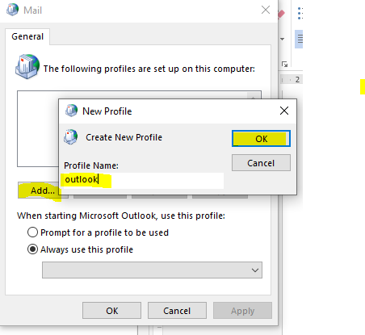

4>Enter the user details and click on next

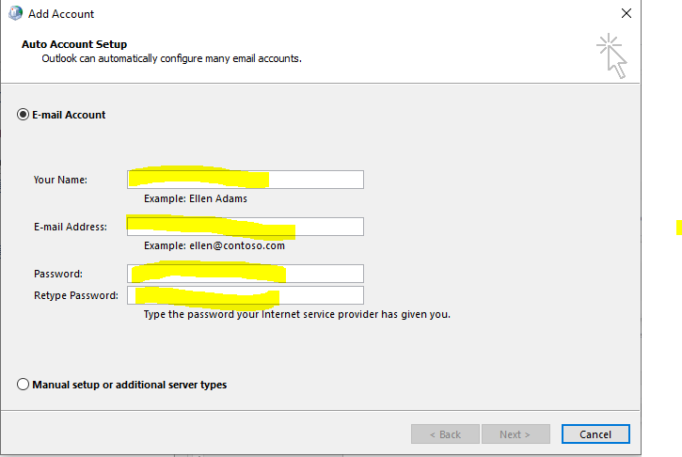

5>click on finish

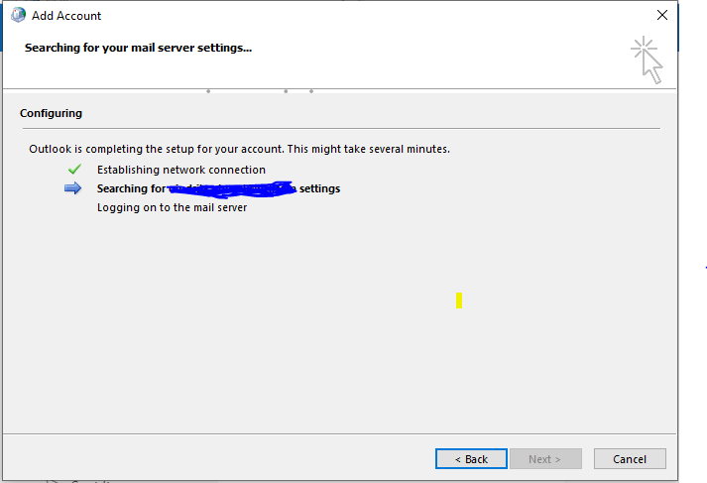

6> Select the newly created profile and click on ok

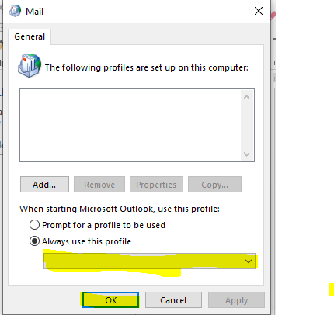

After that open outlook. It will take time to open outlook as it will create all new configurations and local ost files. Next time it will not take that much time.